Defining Galloway Beef

A scoping study and member consultation
on behalf of Galloway Cattle Society

Summer 2016

Background

1.1 Introduction
The Galloway is one of the oldest and purest of Scotland’s native cattle breeds and while the resulting beef is widely considered to be a premium meat, there exists within the market place, particularly in southern Scotland, considerable consumer confusion about the term Galloway Beef. This is due to the dual meaning of the term Galloway.

To the consumer, does Galloway Beef mean beef from cattle reared in Galloway, or does it mean beef from Galloway cattle? This lack of clarity is considered by the Galloway Cattle Society to be one of the stumbling blocks to securing a premium price for the meat, and therefore encouraging the growth of the breed.

This scoping study seeks to explore means by which ‘beef from Galloway cattle’ can be defined, with the objective of creating clarity for purchasers and, in the longer term, securing a more consistent, premium price and more stable demand for the beef.

The study will identify a recommended approach for the future definition of ‘beef from Galloway cattle’ for consumers. This will enable clear direction to be provided to support the future promotion and marketing of the beef product. The long term goal is to encourage the hospitality industry and retail butchers to communicate in a more transparent way to enable consumers to have confidence in the product they are purchasing.

1.2 Background
The Galloway Cattle Society is a stable and well established cattle society with an active and engaged membership of 559 members, of which 152 reside in Dumfries & Galloway. There are two main clusters of Galloway cattle farming in the UK, one in the south west of England and the other being Dumfries & Galloway and Cumbria.

The average size of Galloway Cattle herds is 19, such is the nature of hill breeds, however in Dumfries & Galloway there are more commercial, larger herds, with 4 herds in the region in excess of 100 cattle. Numbers of Galloway Cattle have been broadly stable for many years, however the past two years has seen a slight decrease in registrations, and two significant herds in the region have been lost this year due to retirement.

There has been a long term desire from the membership to address the confusion around the term ‘Galloway Beef’. The use of the term ‘Galloway Beef’ alongside images of iconic Belted Galloway cattle is becoming increasingly inappropriately used to imply meat is from Galloway Cattle, when in fact it is beef sourced from Galloway. This issue of consumer confusion is very specific to the geographic area around Galloway, where the term ‘Galloway’ is used as an indicator of quality, mainly across the south of Scotland and into Cumbria.

Beef from Galloway cattle, in line with many native breeds, has very distinct properties that differentiate it from more commonly available continental breeds; particularly in relation to the marbling of fat through the meat, the texture and the balance of omega oils. Beef from more widely available continental breeds that are reared in Galloway is a structurally different product. When consumers encounter continental bred beef labelled as ‘Galloway Beef’, however high the quality, the eating experience is intrinsically different and thus implies to the consumer, at best, that Galloway Beef is an inconsistent product, and at worst suggests the product is ‘nothing special’.

Finding a solution to defining ‘Galloway Beef’ will allow product differentiation and support consumer confidence. It is envisaged that this will lead to increased consumer demand for beef from Galloway cattle. In turn this will enable premiums for this quality meat to be realised which will help arrest the decline in breed registrations and will significantly help the commercial proposition of beef from Galloway cattle for farmers in the south of Scotland.

1.3 Approach
The Galloway Cattle Society has commissioned this study in order to identify a recommended approach for the definition of beef from Galloway cattle for consumers.

The study has been informed by:
- Extensive consultation with Galloway Cattle Society members
- Consultation with other key Galloway Beef stakeholders
- Desk research into the viability of a range of approaches

The structure of this report is as follows:

Section 2: Presents an overview of the market, trends and current brand positioning of premium and native breed beef within the UK;

Section 3: Outlines the themes and opportunities emerging from the membership and stakeholder consultation;

Section 4: Presents a recommended approach to defining beef from Galloway cattle and outlines steps the Galloway Cattle Society might want to take next;

Section 5: Summarises the key findings and recommendations of the study.

Premium and Native Breed Beef in the UK

This section presents a desk review of a selection of known research and trend reports to explore the market opportunity for a new Galloway beef brand within the UK.

2.1 The Market Opportunity

While the UK beef market has been in overall steady decline for the past 20 years, there are clear opportunities for growth for brand led or product differentiated beef.

Indeed recent data suggests that demand for beef from native breed cattle is increasing steadily. The Scottish Red Meat Industry Profile 2015 found that:
“Premia offered to producers selling finished cattle in recent years have led to an expansion in the popularity of the Aberdeen-Angus breed in Scotland.

“Having increased by 6% in 2014, the rise in Aberdeen Angus-sired calves slowed to 1% in 2015, with numbers up to 89,800 head. However, this was insufficient to maintain its share of the total, which slipped back to 15.7% from 15.9% in 2014. The popularity of other sires, in general, rose strongly. Of the native breeds, the number of Beef Shorthorn-sired calves rose by 16.5% while there was a 24% increase in Herefords.”

Steady growth across the sector may be explained by the success of native breed marketing such as the Morrisons Native Breed Scheme, which several members of Galloway Cattle Society participate in. Provenance is increasingly reassuring to consumers who are looking for something ‘real’ amid the noise of a chaotic consumer environment. Marketing initiatives such as Tesco’s recent fake farm brands labelling evidences the desire from consumers to buy origin defined fresh foods.

Across the wider marketplace beef from grass fed native breed cattle is increasingly being considered as a ‘healthy’ meat, with the product ideally positioned to respond to a number of emerging food trends that are likely to become increasingly influential in purchasing decisions over the next 2-3 years.

Keynote speeches from the recent (July 2016) UK Wagyu Revolution Conference stated that:
“The inherent qualities of Wagyu beef are tenderness, marbling and healthy eating which drive premium and profit. A key message from the Conference is that demand for Wagyu will continue to outstrip supply for many years so those getting on board now will be well-rewarded into the future."

While August saw the launch of the UK’s first dedicated Wagyu Beef store in Scotland, a sister company to Highland Wagyu in Bridge of Allan: http://tinyurl.com/hxl9dmp

Those Wagyu beef qualities are also to be found in beef from Galloway cattle. In addition, the history of the Galloway breed, its low environmental impact and its iconic imagery presents additional value adding aspects that could assist in building a brand narrative to position the meat firmly within the premium market segment.
2.2 Market Trends

Mintel’s Global Food and Drink Trends forecast for 2016 identified 12 trends that are currently impacting on consumer behaviour and purchasing decisions. Of these seven are directly relevant to supporting the idea that a well defined brand for beef from Galloway cattle could find favour with consumers:

Artificial: Public Enemy No. 1: “Consumer demands for natural and ‘less processed’ food and drink are forcing companies to remove artificial ingredients.” Beef from Galloway cattle is ideally placed to capitalise on a natural proposition.

From the Inside-Out: “Consumers are recognising that diets can connect with the way they look and feel.” The health properties of beef from Galloway cattle, particularly the Omega 3 properties, if well communicated will find favour with consumers who are driven by nutrition.

Based on a True Story: “Consumers have been romanced by product origin, ingredients or inspiration stories.” Beef from Galloway cattle has a wonderful story to tell, this will be a hugely important element of establishing a brand.

e-Revolution: From Carts to Clicks: “While the internet has not yet vastly changed the landscape of grocery shopping, innovations encourage consumers to think outside traditional physical retailers.” Consumers are changing their food purchasing habits, this is worth considering when exploring how supply chain innovation might support the growth or accessibility of beef from Galloway cattle.

Diet by DNA: “Interest in natural and ‘getting back to basics’ has boosted ancient grains and superfoods, fostering a principle that age-old staples are better than today’s manufactured options.” Beef from grass fed native cattle is already finding favour with proponents of clean eating. The ancient status of the Galloway breed, the way it is typically reared and the resulting meat are all a good fit with this trend.

Good Enough to Tweet: “The rise of food-centric media has sparked new interest in cooking, not only for the sake of nourishment, but for the purposes of sharing one’s creations via social media.” The rise and rise of social and digital communications provide a cost effective marketing channel through which beef from Galloway cattle could be targeted at a niche audience.

Fat Sheds Stigma: “Consumers’ awareness of the many sources of good and bad fats is ushering in a paradigm shift in which fat content is not the first and foremost consideration in the search for healthy products.” The distinct fat properties of beef from Galloway cattle, if evidenced, are a very strong fit with this high profile emerging trend. Recent UK based research has further highlighted a shift in nutritional advice which increasingly recommends diets that are low in carbs and sugars, but high in good quality protein and good fats.

Online Sales: A supply chain opportunity
More recently research has shown an increasingly large shift in the way UK consumers in particular, are purchasing food - away from physical supermarkets towards digital channels. This presents opportunities for innovative supply chain development.

Mintel’s Online Grocery Retailing UK 2016 report found that in the UK 29% of UK online grocery shoppers are shopping for their groceries more online now than 12 months ago. Today, as many as half (48%) of Brits are current online grocery shoppers. One in ten (11%) do all of their grocery shopping online, with a further 12% doing most of their grocery shopping online. The main reason consumers cite for shopping online more is convenience, with 60% of people who are shopping more online doing so because it is more convenient than visiting shops.

Partnering with a direct to consumer sales channel who is already supportive of the breed, such as Galloway Quality Meats, might be an ideal approach to developing a flexible and accessible route to market.

2.3 Established Native Breed Brands

Aberdeen Angus
Arguably the most iconic premium quality beef, the Certified Aberdeen Angus scheme has been running since the 1980s and the Aberdeen Angus brand is widely considered a mark of beef quality.
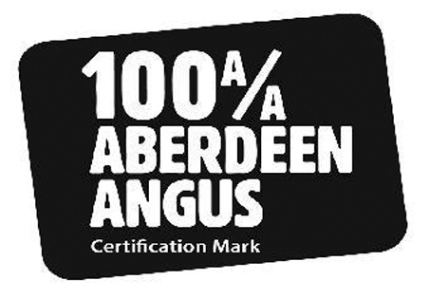
Certified Aberdeen Angus beef products can be found in all retail multiples and the beef is widely available in the hospitality sector, from fast food chains to high quality restaurants.

The Aberdeen Angus Cattle Society hold multiple trademarks related to their certification schemes, however the details and the requirements of those schemes are not easily accessible to consumers. The current branding seems to imply a 100% or pure Aberdeen Angus when certification requires only 50%.

Should the Galloway Cattle Society go down the certification route there is a decision to be made as to whether or not to certify only meat from pedigree animals, or whether to follow the approach of most native breed cattle societies and certify at 50%. There is an argument to be made for both approaches.

Certification of only pedigree animals would ensure a consistently exceptional quality meat. From a consumer point of view the brand position of that meat would be akin to Wagyu in its product properties and premium positioning. However, certification at 50% would enable much greater supply and greater freedom for farmers to participate in other schemes, but could lead to an inconsistent consumer experience.

Shorthorn Society and Morrisons
Morrisons recently cemented their commitment to the Shorthorn breed by forming an exclusive partnership with the Beef Shorthorn Society which will promote the use of registered and DNA recorded Beef Shorthorn bulls in the UK suckler herd. The partnership has been six years in the works and will see the Shorthorn Cattle Society supplying beef exclusively to Morrisons for an undisclosed sum. Ultimately the goal of the partnership is to launch a new Shorthorn Beef brand to be piloted in 2017, with the implication of a move to 100% Shorthorn. Full details of the scheme and future plans can be found: https://issuu.com/acstededesign/docs/morrisons_shorthorn_leaflet_2016b

An additional 16,000 native breed cattle per year will be required, up almost 10% on current throughput. Beef Shorthorns and their crosses will receive 20p/kg over the base price, or up to £75 head, while other native breed cattle will receive a 10p/kg premium.

In an announcement Morrisons stated:
"The special premium for Beef Shorthorns reflects the supermarket chain’s long-standing commitment to the Beef Shorthorn breed on its own farm at Dumfries House in Scotland. Morrisons has developed a new feeding regime specifically to enhance the inherent eating quality of the breed and produce a premium product."

The Shorthorn Society secretary commented:
"Approximately 27,000 Beef Shorthorn and Beef Shorthorn cross calves registered by BCMS in 2010. This record number demonstrates how the commercial value of the breed is more widely recognised than ever before. A major attraction of the breed has been the ability to produce functional suckler cows: now that we have a premium scheme for Beef Shorthorn beef even more farmers will be encouraged to use the Beef Shorthorn bull in their commercial suckler herds."

There are upsides and downsides to the Galloway Cattle Society developing a partnership with a retail multiple. Working in partnership with a retailer would bring with it retailer driven definitions of finishing standards, would take considerable administrative support by the Society and would take a long time and a lot of resources to secure. However, such an approach would also raise the profile, provide a steady demand for the meat and is an approach that would likely be well supported by Scotland’s food and drink development programmes and organisations.

It is an approach that is well worth exploring, potentially with a retailer with flexibility and seasonality in their product ranges, such as Aldi.

2.4 Methods of Definition

Trademarking of society breed certification scheme logos combined with signing up to the Voluntary Beef Labelling scheme is overwhelmingly the most common method by which breed societies communicate the qualities and protect the reputation of their native breed beef.

Voluntary Beef Labelling
EC legislation requires beef labelling information, apart from compulsory labelling, to be approved by the authorities and checked by recognised verifiers, such as SFQC Ltd. This includes labelling of the breed or cross breed information. It can also include labelling regarding the method of production or the method or length of maturation. http://www.gov.scot/Topics/farmingrural/Agriculture/Livestock/Meat/Beef/Labelling/scheme/VoluntaryBeefLabelling

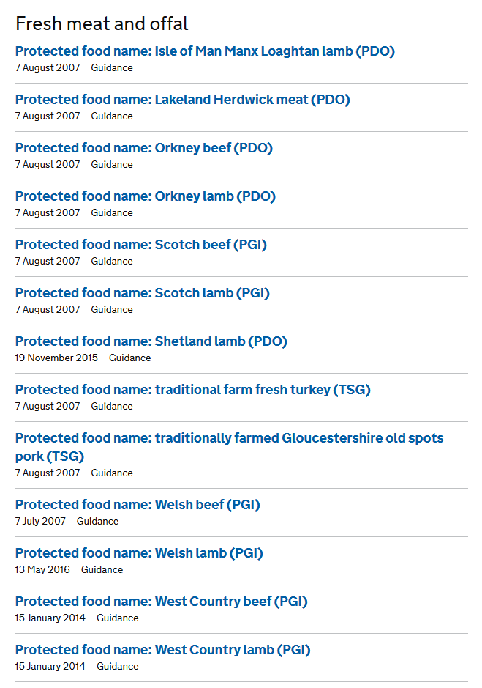
The scheme requires submission of the exact wording being applied to labels, a detailed description of what is meant by those terms and a copy of the labelling material. The application form states:

“Labelling covers wording on tickets, receipts, blackboards and in advertisements and literature at the point of sale and on websites.”

The scheme requires an outline of how the accuracy of the labelling information will be guaranteed, including a description of a traceability control system. A verifier will need to be employed by the Society or supply chain partner to check the accuracy of the claims.

Before commencing the creation of a certification scheme it is recommended that the Galloway Cattle Society speak with SFQC to ensure best practice and a robust, compliant traceability.

PGI
The EU protected food name scheme highlights regional and traditional foods whose authenticity and origin can be guaranteed. While the EU-wide protection this scheme offers would be the preferred option by the Galloway Cattle Society, such protection is unlikely to be awarded to beef from Galloway cattle.

This scheme is most appropriate to products where there is a clearly defined and self contained geographic boundary, such as islands or countries, as can be seen from the current list of awarded PGIs for fresh meat (opposite). This is not the case with Galloway cattle, with clusters across the south of Scotland and the south west of England.

Trademarking
For most cattle societies trademarking is the most appropriate means of defining the meat resulting from a specific breed. There is a mix of trademarks for cattle societies and for society certification schemes. For example:
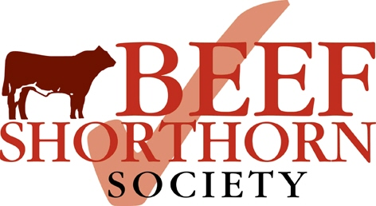

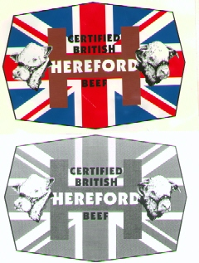
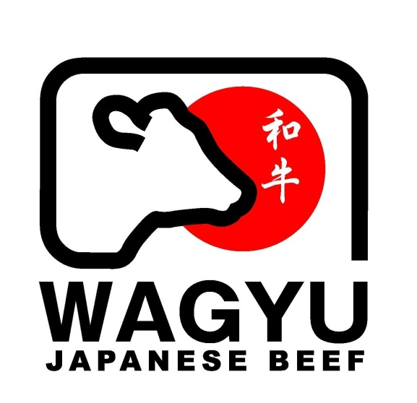
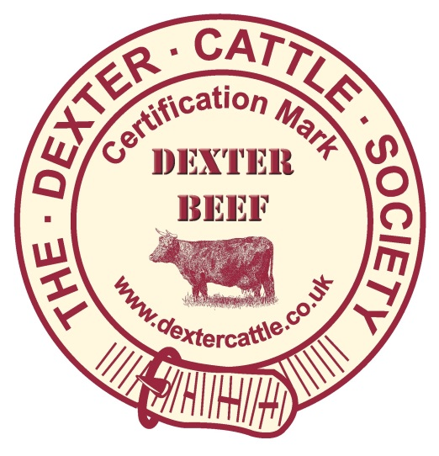

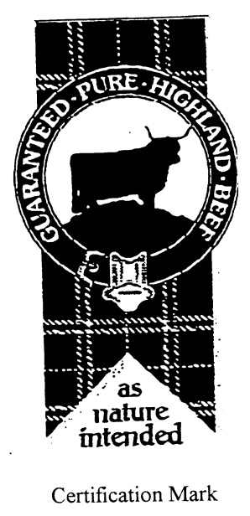
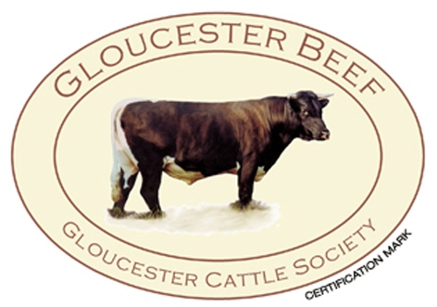

Trademarking is a relatively straightforward process. A certification scheme for beef from Galloway cattle would fall under Class 29. Advice on pursuing this approach could be sought from Scottish Enterprise’s intellectual asset advisor.
Member and Stakeholder Consultation

3.1 Overview

The member and stakeholder consultation took place over a two month period between Feb and Apr 2016. Consultation with members focused mainly on breeders who finish their Galloway beef. In-depth telephone interviews, typically lasting between 30-90 minutes, took place with members who had responsibility for herds ranging in size from 5 to 650. The member farms selected were identified from a list supplied by the Galloway Cattle Society, which prioritised south of Scotland and North of England member farms. The consultation sample was determined by those members available and happy to participate in the consultation.

There was widespread consensus across the members interviewed about the strengths, opportunities and current weaknesses of the breed. There is no question in members’ minds that beef from Galloway cattle is an extremely high quality product, and that Galloway cattle are one of the more sustainable and economically accessible breeds.

Members felt there was significant untapped potential, indeed the potential of the breed was the single most important theme emerging from the consultation. In addition, the identification of how to unlock the potential of the breed - through marketing and brand building - was remarkably consistent.

Members stated they felt there was a critically important role for the Galloway Cattle Society to play in facilitating this, and in becoming an information hub for the breed. Some members also noted there was timely emerging opportunities within the south of Scotland, in particular relating to a new Galloway-friendly owner at the local abattoir.

Members were pragmatic about the current weaknesses in developing the breed, in particular the lack of volume in supply, the seasonality of supply and the demographics of current members – in short the need to increase breed numbers and encourage younger farming entrants to farm Galloways.

There was also a frustration at previous lack of success in promoting the breed, and lack of partnership working with other organisations. However, those members who felt frustrated during the consultation were the most enthusiastic about the potential of the breed and the potential of a programme of marketing led by the Society.

The only threat identified by members was product consistency. A number of members suggested that product consistency could best be achieved by a marketing scheme that focussed on pedigree Galloways, while others recognised that approach would exacerbate supply issues.

3.2 Current Routes to Market

From the sample poll taken, 39% finish all their beef, 33% sell all their beef store, 28% sell a mixture of finished and store cattle depending on their type of farm and farming policies employed.

It was noted that most cattle are mainly finished on grass with a bit of grain feeding to finish ensuring the rich marbling and fat cover of the meat. It was recognised that those finishing all their cattle, on the whole, were able to produce their own grain and silage.

Routes to market include Scot Beef, Morrisons Native Breed Scheme and direct sales. A number of breeders interviewed said that they used to finish cattle but found it was too expensive due to rising feed costs. Other contributing factors for breeders not finishing cattle included not having facilities to house cattle, cashflow and securing better margins when selling as store. Routes to market for store cattle include Kilnford, local native calf sales and local finishers.

During the member consultation genuine optimism was clearly evident, with a number of breeders planning to increase the size of their herds over the coming few years. Breeders who finish beef from Galloway cattle currently supply wherever they have found their own market but there was overwhelming support for a dedicated scheme, should one come to fruition.

Two members provided confidential data on benchmarking costs they had carried out on their own farms comparing their continental cattle versus their Galloway cattle. The Galloways consistently proved to leave a considerably better margin per cow over a 5 year period. Although not normally bulled until two years old a Galloway cow will traditionally have 2 – 3 more calves than a conventional suckler cow during the course of her lifetime, and are very easy outdoor calvers.

It was also noted that one breeder is continuing to reduce his continental cattle numbers in order to reduce his output costs (such as fertilisers and feed) and introduce more Galloways which are already improving his bottom line and profitability margins with less labour input. This further illustrates that Galloways are well suited to low input, sustainable farming systems.

3.3 Strengths
As a native hill breed Galloways produce a natural beef product with significant environmental benefits and taste difference. They do not require an intensive diet and do not need to be housed over the winter. They rake on the hills, are not forced and are slower maturing which in turn produces a carcass which has a finer grain of texture producing a meat which is succulent and has excellent marbling, flavour and taste.

Quality:
“Galloway beef is the best product in the world. It has to target a niche market – and there has to be one out there, needs expertise to tap into that market and co-ordinate the marketing and promotion of ‘Elite Beef’.”

“Galloway is a much better proposition for nice sized cuts of meat (and steaks). If marketed properly, it will equal if not supersede the quality of other highly acclaimed beef including Aberdeen Angus and Waygu – it’s all down to marketing!”

Sustainability & Cost Effectiveness
“With proper attention to genetics and breeding finished carcass weights are no less than continental crosses. Although they take longer to finish than conventional cattle, they do so at much lower costs.”

“Currently building Galloway herd up through a Rewilding scheme. Previously had 60 continental cattle and have reduced continentals currently to around 25, and looking to reduce further to increase Galloway herd.”

3.4 Opportunities

Potential
“There is huge potential through targeted marketing and PR activity and must be embraced by the Society to support its members and breed.”

“If there was a market and infrastructure to allow sales of Galloway beef to grow at a premium price, then would definitely be interested. I think this project is a magnificent idea. Society needs to lead on it and bring in supporting services to make it happen. It would encourage new avenues to open up, as well as bringing more Galloway bullocks into the system if there was a premium for the end product.”

“If a brand can be created successfully then there will be a premium for all beef across the supply chain, both finished and store cattle. This would be a great incentive for new entrants.”

“The Galloway Cattle Society don’t realise the potential of the breed. Pure Galloway Beef needs to be differentiated from ‘other beef’.“

“Needs a lot of promotional work done to raise awareness of the high quality of Galloway beef. It’s all about telling the story to build up trust and loyalty. Won’t get any better beef from any other breed but needs to be marketed as such.”

“Aberdeen Angus is a global success story, it started somewhere, and there is no reason why the Galloway cannot match and beat their success.”

“The basis of this project is exactly what is needed to grow local demand and work with the hospitality sector, retail and butchers to define Galloway Beef to position and brand it through telling the story. It’s all about labelling and definition. A lot of work also needs to go in to educating the public.”

“I’m more interested in promoting the breed and creating demand through marketing and promotion, on a seasonal basis, than interested in getting a premium for the beef. Demand will create premium once established.”

“Needs a dedicated team of enthusiastic people to develop branding, positioning and targeted promotional and marketing campaigns to make consumers more aware of the premium quality of Galloway Beef.”

“It’s a high end commodity and not suited to everybody but target at a specific niche audience.”

“There are individual butchers/retailers selling it as a specialised product at the moment which seems to be very successful – Ben Weatherall; Scott McKinnon; Kilnford. No reason why this can’t be upscaled to have bigger impact through targeted promotion and marketing.”

“Through targeted promotional work, which will create demand, a premium will be paid for quality Galloway beef. This has an effect right down the supply chain from processors, finishers and those selling store cattle making it more profitable for everyone.”

Information Provision
“An area within the website could be developed to let potential butchers/buyers know who had beef available at any given time. Someone would need to manage this to keep it updated.”

“Need to have a central database/network set up for butchers/buyers to access to see where the availability is to supply the demand. Has to work from the abattoir out.”

“Galloway Cattle Society would need to co-ordinate bullocks available at any given time so that there was a central database for interested parties to access. This could potentially change everything and open up so many marketing opportunities.”

Supply Chain
“I’m not interested in a supermarket contract. Need to focus on working with independent butchers and retailers.

“Now that there has been a change of ownership at Lockerbie Abattoir, and they are familiar with fattening beef from Galloway Cattle, and are delighted with the results, there might be some new opportunities.”

3.5 Weaknesses
Undervalued:
“No premium on end product which is disappointing.”

“The Galloway Cattle Society have not taken the lead to create markets for Galloway Beef, something needs to be done now before it is too late.”

Supply
“Due to lack of numbers available it would need to be marketed as a seasonal product, and therein lies the difficulty.”

“Appreciate that there is no stable supply which weakens demand, but market as seasonal.”

“Need more people producing it to market on a bigger scale. Not enough producers to supply at the moment.”

“Lack of supply to meet demand. *Named person redacted* was involved many years ago when the Galloway Cattle Society and FMC took a stand at the Royal Show to promote Galloway Beef. It floundered because of lack of numbers to supply.”

Need for New Entrants
“Mind set needs to change to encourage younger breeders into the sector and create a thriving breed that is highly desirable both to produce and to eat.”

“Youth is the future of anything and if this gathers momentum will encourage young farmers to buy into the breed. Galloways are one of the more affordable breeds to get started with.”

“Young people need to be encouraged into the breed and if we can create a market for the quality beef produced, this will bring more people into the breed who are ambitious to succeed.”

Previous Lack of Engagement
“Don’t think Morrisons have been approached by the Galloway Cattle Society. Should be working more closely as there could be an opening there if ground work done. “

“Individuals and small groups of, mainly, farmers have tried various schemes to promote the natural, hill bred Galloway but it has never taken off. It needs to be led by the Society on behalf of all its members and pull in supporting services to hit the ground running and have instant hits straight away to build momentum.”

“Society should also work more closely with organisations such as RSPB and SNH who pro-actively seek cattle to graze marginal land to improve habitats and biodiversity. Galloways are ideally suited to this type of land and have excellent foraging ability.”

3.6 Threats

Product Consistency
“Needs to have consistency in quality. Big question is - Is this focusing on pure Galloway or Galloway X? Galloways are naturally a maternal breed producing cross replacements e.g. Blue Grey Heifers. There are lots of different X’s which could potentially describe Galloway Beef – what are you describing? Needs to have consistency in quality.”

“The reason to market only pure Galloways is for consistency in quality rather than have cross bred eligible which changes the dynamics completely and doesn’t guarantee consistency.”
“Must focus on pure Galloway Beef and not go down the route of the Aberdeen Angus where 50% genetics ensures that beef can be sold under their ‘brand’. This doesn’t allow for consistency in the beef if cross breeds are used. It will take longer to get numbers to keep pure, but smaller amounts, initially, isn’t necessarily a bad thing if marketed right.”

“Breeders finish their cattle to suit the specification required by the processor they supply to get the grades required to secure a premium, which doesn’t always suit the Galloway. Need to look beyond this to what the end consumer is wanting to market Galloway Beef.”

Defining Galloway Beef

4.1 Overview

The approach taken by other cattle societies suggests there is a significant opportunity for Galloway Cattle Society to make considerable progress in defining beef from Galloway cattle through a mix of trademarking, product assurance, research and marketing.

In many respects the Galloway Cattle Society will be playing catch-up in a market segment which already has some very prominent and well established brands. However, beef from Galloway Cattle has a number of particular selling points that, if well communicated through branding and marketing, should enable the beef to be successfully positioned as a premium product.

Key to the success will be securing a descriptive but impactful brand that differentiates beef from Galloway cattle as distinct from beef from the region of Galloway. Retention of the term ‘beef’ within the brand is recommended to aid clarity of communication. There are several approaches the Galloway Cattle Society could take here:

Pure Galloway Beef: ideal if focussing on pedigree beef

Assured Galloway Beef: provides a strong quality impression

Certified Galloway Beef: aligns with 50% schemes, such as Aberdeen Angus, and thus likely to be well understood within the industry

Native Galloway Beef: highlights the ancient origins of the breed

In moving the project forward to develop a solution that defines the beef product, develops a route to market, provides clarity of consumer communication and secures the Galloway Cattle Society’s leading role in managing the development of the breed, the following steps are recommended for the Society.

4.2 Short Term Recommendations

Secure IP Assets and Secure Immediate Funding
- Decide on a trademarkable brand name for the beef product.
- Immediately secure digital assets (website domain name, twitter handle, facebook page name and other appropriate digital and social assets).
- Speak with Scottish Enterprise’s IP Advisor (Stuart Watson) to gain advise on securing intellectual property relating to new brand.
- Apply for Scottish Enterprise design grant to create a brand identity and brand narrative for Pure Galloway Beef.
- Trademark and Register the name and resulting logo design.
- Apply for Interface grants for University research to evidence distinct nutritional properties of Pure Galloway Beef, including omega oils. Explore incorporating results into ‘best practice’ or set of standards for finishing beef.
- Create a certification or accreditation scheme for 100% Pure Galloway.
- Seek additional funding opportunities to assist in developing the project.

4.3 Medium Term Recommendations

Develop Sales & Marketing Resources
- Identify key supply chain partners to identify a clear route to market and method of customer sales fulfilment for the meat.
- Explore potential support for Society in launching a new beef brand via supporting organisations, such as Connect Local or Scotland Food and Drink.
- Explore renegotiation of Galloway premium or Galloway branded product with retail multiples.
- Determine sales method for immediate branded meat.
- Identify and secure resources required to develop and deliver a sales and marketing strategy, eg explore LEADER funding
- Complete research project and launch findings.
- Develop sales and marketing assets, including photography, packaging, point of sale and added value assets (ie recipe cards) to support sales activity.
- Establish defined product and clear customer proposition.
- Launch the new assurance scheme, brand and sales mechanism with a PR and marketing splash.

4.4 Long Term Recommendations

Establish Product and Grow Breed
- Ensure consistent supply of product by growing breed numbers.
- Establish breed & brand ambassadors to champion product.
- Deliver long term implementation of sales and marketing strategy to enable establishment and success of the new brand.

Conclusion and Summary

Key Findings
- Premium and native breed beef is evidently becoming sought after by a particular market segment who seeks provenance, quality and a distinct product.
- The attributes of beef from Galloway cattle are a good fit with emerging food trends.
- The attributes of beef from Galloway cattle appear to be a good fit with changes to accepted nutritional advice.
- Several cattle societies have well established quality assurance and accreditation schemes that appear to be working well.
- One major retailer is investing heavily in promoting breed defined beef, Shorthorn, within a long term marketing and breed development project.
- Marketing, promotion and supply chain development are likely to be critical factors in establishing a brand for beef from Galloway cattle and thereby create consumer demand for the breed.
- 100% Galloway beef is widely recognised by members and supply chain partners as being a premium product that, when finished and hung properly, is one of the best meats in the world.
- Members overwhelmingly believe the potential of the breed has been nowhere near realised.
- Members and supply chain partners believe that with a programme of marketing the potential could be realised. However members are realistic in their expectations, understanding that there are currently problems with the availability of steady supply.
- Members consistently highlighted the dual importance of educating consumers and promotion of the product to consumers.
- Many members expressed concerns at a potential decline in breed numbers. They also highlighted the opportunity the breed presents to young farmers in terms of accessibility and return.
- Members feedback suggests that the World Congress was a huge success and proves that the breed has global recognition. Now is the time to capitalise on the success of the magnificent show of cattle and huge success of the programme of events and to build on this success by launching a programme of marketing and brand development activity to support the sales and grow the market for beef from Galloway cattle.

Recommendations
- Secure digital, social and intellectual property assets.
- Apply for grants to support brand development, project development and research to quantify product claims.
- Create a certification or accreditation scheme.
- Apply for grants / resources required to develop and deliver a sales and marketing strategy.
- Identify key partners across the supply chain and identify preferred sales channel.
- Establish defined product and clear customer proposition
- Launch product to target markets with seasonal campaigns.
- Ensure consistent supply of product by growing breed numbers.
- Establish breed & brand ambassadors to champion product.

